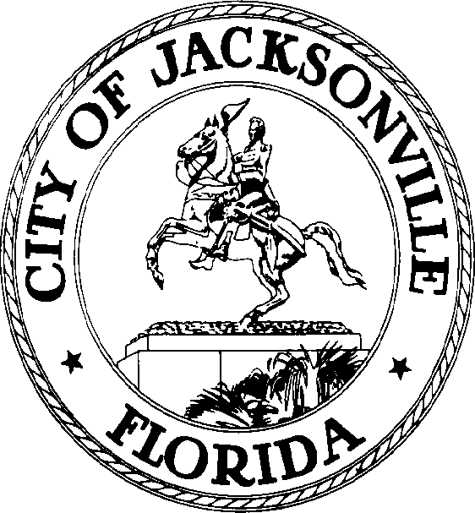

SAM C. NEWBY  Council President Group 5, At-Large  E-Mail: snewby@coj.net | OFFICE OF THE CITY COUNCIL | 117 West Duval Street City Hall, Suite 425  Jacksonville, Florida 32202  Office (904) 255-5219  Fax (904) 255-5230

NOTICE

FEBRUARY 25, 2022
4:00 P.M.

Notice is hereby given that the Council Member-Elect Nick Howland, Group 3 At-Large, will be a member of Transportation, Energy, and Utilities Committee (TEU) Committee replacing Council Vice President Terrance Freeman upon being sworn-in.

Council Member-Elect Howland will be a member of the Rules Committee replacing Council Member Randy White at the Rules Committee meeting immediately following the Council enacting 2022-1, Redistricting Ordinance.

ADA Accommodation Notice
Pursuant to the American with Disabilities Act, accommodations for persons with disabilities are available upon request. Please allow 1-2 business days' notification to process; last-minute requests will be accepted but may not be possible to fulfill. Please contact Disabled Services Division at: V (904) 255-5466, TTY (904) 255-5476, or email your request to KaraT@coj.net.

SN/ypm

XC: Council Members
Cityc@coj.net
Jessica Matthews, Chief, Legislative Services Division
Jeff Clements, Chief, Research Division
Jason Teal, OGC
Margaret “Peggy” Sidman, OGC
Electronic Posting – 1st Floor City Hall
Web Posting
Media Box

